Creating Online Language Learning Opportunities for MLLs/ELLs
Some Suggested Guidelines

- Start with a current/future grade level unit of instruction (ELA, Math, Science, Social Studies, etc.). Work to implement the core standards and objectives outlined for the unit with your students.

- List the content and language objectives for the unit. Remember that language objectives should include communicative objectives (discuss, explain, name, list, compare, etc.) that are appropriate to the proficiency levels of your students (See WIDA Key Uses Documents; https://wida.wisc.edu/teach/can-do/descriptors) as well as language learning objectives (how English works—the forms and structures of English—not only new word learning, but also work on language length and complexity, including the forms of English (plurals, past tense, adverbial phrases, preposition usage, etc.) as well as developing greater complexity at the sentence and paragraph levels.

- Plan proficiency-appropriate language learning activities. Use the WIDA scaffolding chart to plan supports for the activities you create for your students.

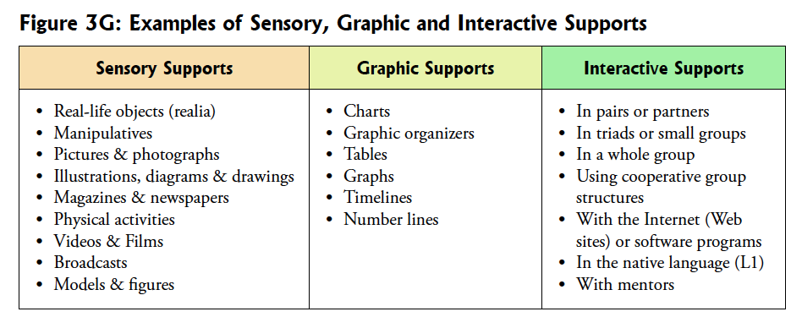
See “Online Resources and Apps for Multilingual Learners/English Learners” for ideas and resources (sent as a blast and also will be posted on the RITELL website)

- If your students are Entering/Emerging (or even low Developing) you may need to expand the text set so that there are entry level texts for your students. You might also find on grade level texts in students’ home languages for the unit. You can hunt for books on Permabound.com by theme/topic as this site gives the reading levels of all the books it lists. This may allow you to find entry level books for your students. But you can also search on Amazon or Barnes & Noble and any of the companies that publish books at different levels (Capstone, Benchmark Education, National Geographic Books, etc.)

- Refer to the English Learners Success Forum Guidelines for Standards-Based Lesson Planning for ELs.
https://www.elsuccessforum.org/guidelines
Their planning tools and activities are very useful.

- Plan anticipatory activities/entry to the unit activities for your ELs—teach key vocabulary and build needed background knowledge before starting the unit. Find online tools (Teacher-developed or online videos, read alouds, short demonstration videos, songs, chants, Flocabulary segments, anticipation guides for introductory readings (http://www.theteachertoolkit.com/index.php/tool/anticipation-guide; https://www.readingrockets.org/strategies/anticipation_guide) as you lead into the unit.

- Plan connected Listening, Speaking, Reading and Writing activities for the unit. Use guided protocols to make sure that students are supported through the activities. Give feedback loops to students as you work through the unit (chances to audio record their responses, or to give written responses as they work through the unit). Give students content and language feedback so that their language and content learning progresses.

- If using a piece of Children’s or Adolescent Literature the publisher may give lesson plan ideas for the book. For example, Lee and Low provide Teacher Guides that are quite useful for all of their Multicultural book titles. https://www.readingrockets.org/strategies/anticipation_guide

Often author sites are filled with this type of resource as well. See also https://www.teachingbooks.net/

- Give students ways to communicate with one another and with you in meaningful ways. Allow them to ask and answer questions, share ideas and opinions and so forth. This might involve chat rooms, blogs, cooperative group work through Google Folder activities, etc).

- Make sure that activities push students’ academic language forward to the next proficiency level—stretch their language so that they are given chances to grow. You should expand and refine their vocabulary (teaching a core group of words—see http://www.nysed.gov/common/nysed/files/nov-8-nys_brief-6-of-8_-summer-2017_-hallmark-4-vocab_final_2.pdf-a.pdf and help them grow in the ways they are able to organize their thoughts in sentences and passages (types of sentences—compound, complex, expanded, use of introductory clauses, appositives, descriptive phrases, etc.) .

Prepared by Nancy Cloud
On behalf of RITELL (RI Teachers of ELLs)
March 16, 2020

